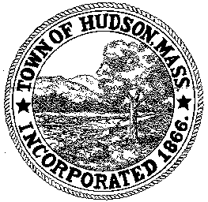

CONSERVATION COMMISSION
78 Main Street, Hudson, MA 01749
(978) 568-2020

Paul Byrne, Chairman W. Minot Wood, Vice Chairman David Esteves, Member

Terrence Joyce, Member Leif Longtine, Member Joseph Rodrigues, Member Al Tashian, Member

Agenda
November 5, 2009 7:00 P.M.

- Preliminaries
  - Open Meeting
  - Roll Call
1.3 Additions or Deletions to the agenda

2.0 Hearings and Appointments
2.1 NOI DEP 190-544
Applicant: Charles Freeman
Location: 35 Worcester Avenue
Project Description: Demolition of the existing house and the construction of
A new single family residence, including a septic system and site grading.

3.0 General Business
3.1 Voucher
ConCom 110509 $1078.88

4.0 Adjournment

